# Proposal for WinVinaya Academy to Virtusa

## Introduction

At WinVinaya Foundation, we provide free training and placement assistance to Persons with Disabilities in Software Development and Banking, Financial Services and Insurance Skills and help them get a job.

About 70% of the Persons with Disabilities who WinVinaya has trained are Hearing & Speech Impaired students and the remaining were either Locomotor Disabled or Persons with Low Vision.

WinVinaya Foundation has been training Hearing Impaired students using Sign Language and for other students with other disabilities using Simple English, in a traditional classroom setting. This limited our positive impact to the society. We could only train about a hundred students a year. From this, we wanted to scale it up to minimum 300 candidates a year. We decided that Digital Learning Platform is the best way to achieve scale without compromising quality.

## Plan and Current Status

WinVinaya Foundation’s digital learning platform will be called **WinVinaya Academy** which will enable Persons with Disabilities to learn Industry Ready skills. In the first phase, WinVinaya Academy will have courses in English, Java, SQL. Courses will be presented in Sign Language and also in simple English, so that People across the Disability Spectrum can benefit. More courses will be added in future phases.

Below is the plan and the current status for Phase-1

|  |  |  |  |  |
| --- | --- | --- | --- | --- |
| S.# | Activity | Due Date | Current Status | Remarks |
| 1 | Choosing Consultants who are experts in Digital Learning Space | Sept-2019 | Completed | Yunikee has been Chosen |
| 2 | Finalize Digital Learning Platform provider | Oct-2019 | Completed | Amphisoft’s E-Box has been chosen. |
| 3 | Design for WinVinaya Academy | Nov-2019 | Completed |  |
| 4 | Develop & Deploy contents for WVA in Simple English | April-2020 | In Progress | Current contents of E-Box for Java, SQL along with WinVinaya contents will deployed |
| 5 | Develop & Deploy contents for WVA in Sign Language | June-2020 | In Progress | Courses in Sign Language is in progress. |

## Innovative design of WinVinaya Academy –

Courses in WinVinaya Academy will have three major modules –

1. **iLearn** – Courses will be presented through videos in ISL (Indian Sign Language) for those who know Sign Language and also through videos in English.
2. **iPractice** – Multiple exercises will be provided for the candidates so that they can memorize the content properly.
3. **iAssess** – will have exercises across various topics/ concepts. It will also have model assessment tests which are similar to what various MNCs ask as part of their selection process.

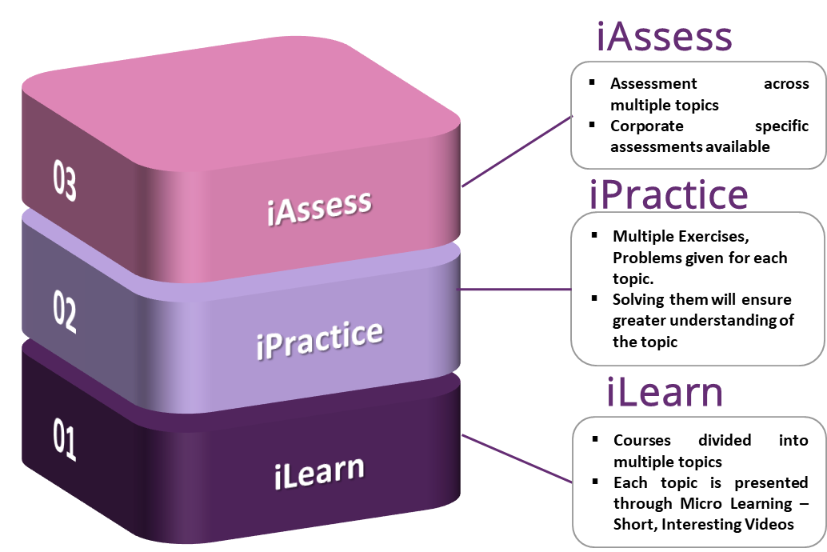

## Key Features of WinVinaya Academy -

**Digital Content in Sign Language**

**for Deaf and in Simple English for Others**

**Hosted on the Cloud.**

**Available Anytime, Anywhere**

**Will be rolled out to Colleges for greater Impact**

**Helps Candidates get Right Job at the Right Time**



## Benefits of WinVinaya Academy

WinVinaya Academy, powered by Amphisoft’s E-Box will benefit tens of thousands of Persons with Disabilities across India to learn industry ready skills, get a job and lead a life with dignity.